Floyd-Warshall’s Algorithm solves the problem Dijkstra's algorithm has with **negative** edges (not negative cycles, because those are mathematically undefined).

* Algorithm setup:
  + Maintain a table (matrix) that has the shortest known paths between vertices.
  + Initialize the table with three possible values:
    - self edges to 0
    - edges by edge weights
    - unknown paths to infinity

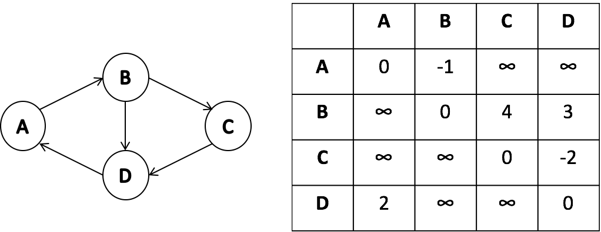

* Algorithm logic:
  + Consider adding every vertex to optimize the existing path:
    - $A→B -1$ vs. $A→C→B ∞$ $A→D→B ∞$
    - $A→C ∞$ vs. $A→D→C ∞$ 
      * $A→D ∞$ vs.

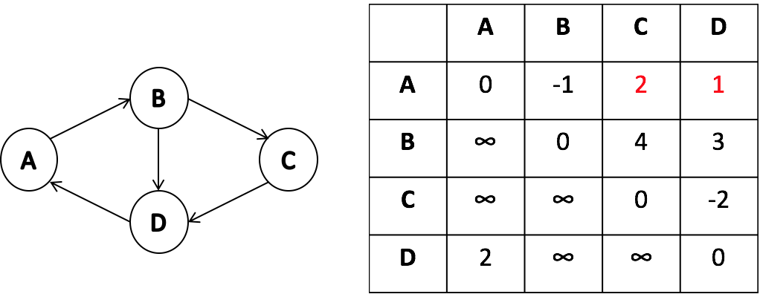

* + Now, do the same with the rest of the vertices (B, C, and D). At the end of the algorithm, we will have shortest paths for all pairs.
* Running time:
 $O(n^{3})$

 + With Dijkstra’s algorithm we assumed optimality → once we find a path from A to B we do not try to find another path from A to B with shorter distance.
  + On the other hand Floyd-Warshall’s algorithm explores all possible paths to determine the shortest path. If we explored all possible paths with Dijkstra’s algorithm, the running time would have been much worse than $n^{3}$.